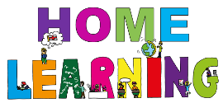    Year 2 Spring Term  Please do the History homework task and choose 2 others to complete over the term (alongside your spellings and reading). Your work will be presented in your creative curriculum books – prizes and house points will be given for effort and originality. |  | 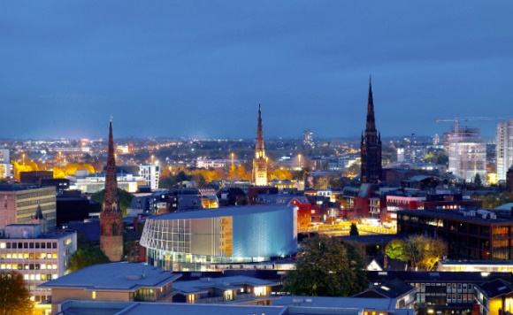  City in the Spotlight
History  How has life in Coventry changed? Can you interview your parents and grandparents about what life was like when they were little and how it is different now? How have places in Coventry changed? What do they remember? Use photo’s and write down information that you find out. | Music  Listen to this song about Coventry, which was written for Coventry City of Culture 2021.  https://www.youtube.com/watch?v=xbHKT4TeGdc  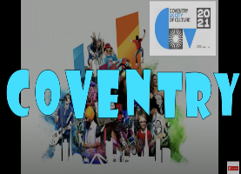  One of the lyrics in the song is, ‘I Love This City’.  Can you make a poster using this lyric and show us what you love about Coventry. | 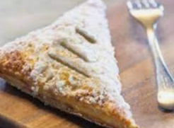  D&T  Try baking Coventry Godcakes – the cakes are really pastries in a triangular shape said to represent the Holy Trinity. You can fill them with mincemeat or jam if you would prefer.  https://www.travelaboutbritain.com/recipes/coventry_godcakes.php  Take some photo’s of your Godcakes and tell us what you think of them!
Art    Practise your sketching skills using line and shade, as you have learnt to do at school. Sketch another monument, building, car or bicycle, linked to Coventry, of your choice. | Science  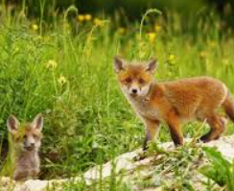  Find out about an animal of your choice and what it needs to survive. What habitat does it live in, what shelter does it create for itself and what does it eat? Show the food chain it is in. Present your research in any way you choose. | 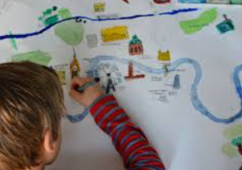  Geography  Create a map of your route to school, drawing symbols for the features that you can see on your way. Include a key.
  PSHE  Think about how you can be a good friend. Make a list of the ways. | Links of interest to support your learning:  Science – what do animals need? https://www.bbc.co.uk/bitesize/topics/z6882hv/articles/z343f82 and food chains https://www.bbc.co.uk/bitesize/topics/zx882hv/articles/zwxwkty  Geography – learning about maps https://www.bbc.co.uk/bitesize/topics/zqj3n9q/articles/zjd66v4  PSHE – friendship https://www.youtube.com/watch?v=ReMq3KX8F94

If you have other ideas of projects you would like to complete at home (which are linked to the topic), you can do these too. Remember, this work will be stuck into your creative curriculum book so make it as creative and engaging as you can!

